Materials
Fencing 500lf (shipping will be expensive)
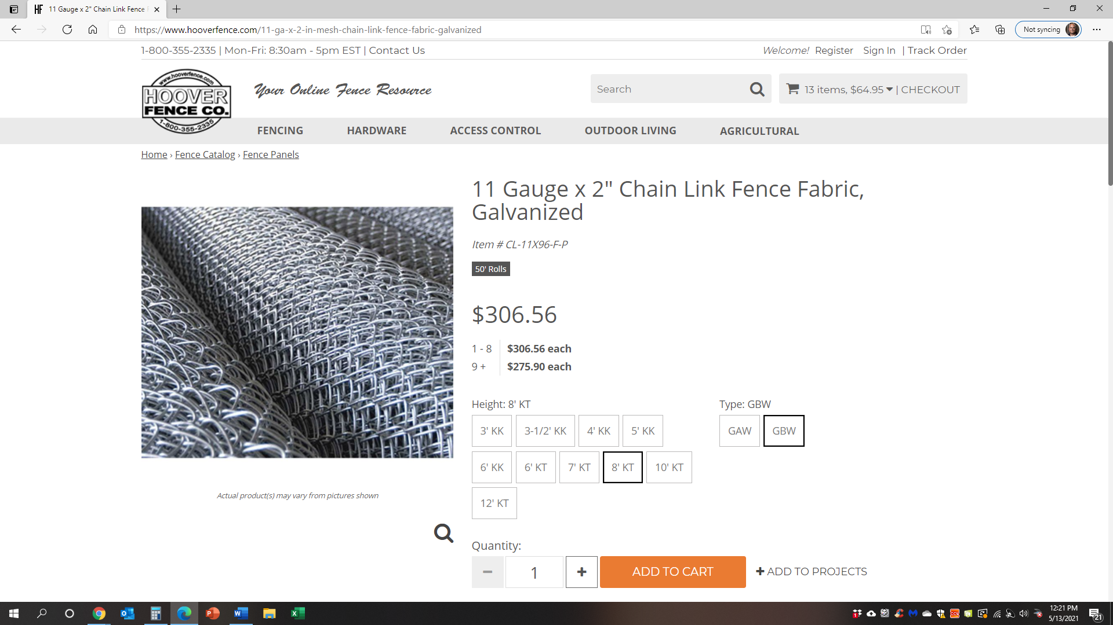

Qty. 14 / 1 5/8” Top pipe
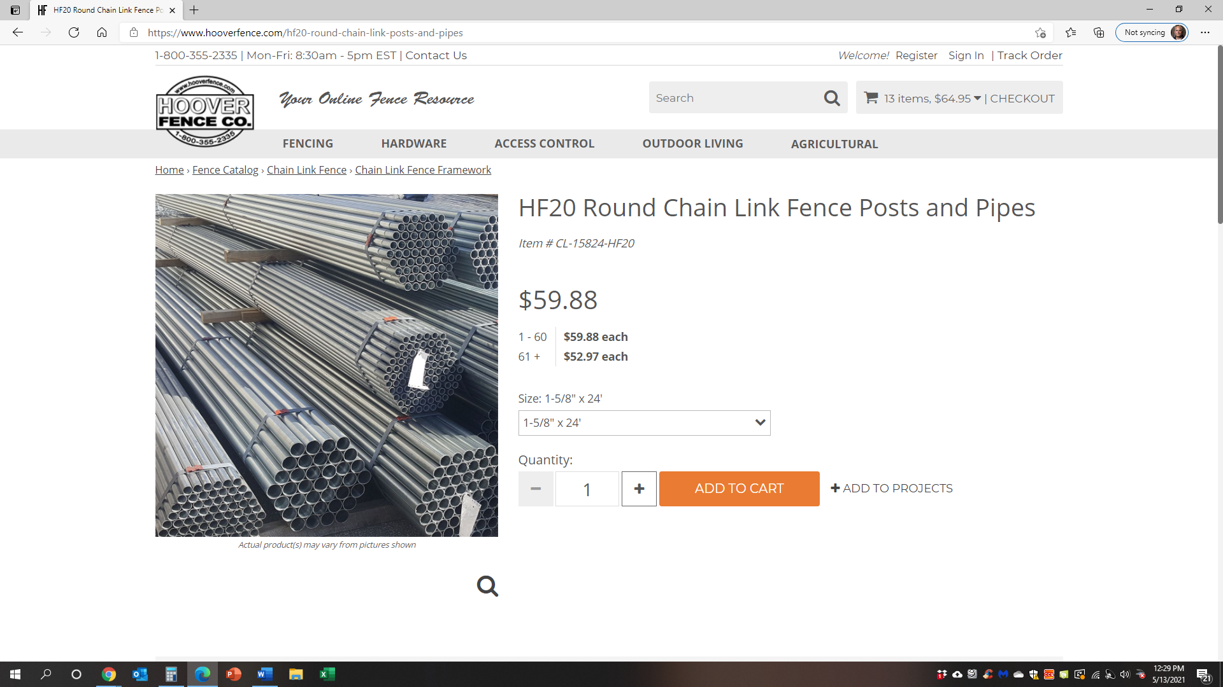

Screws
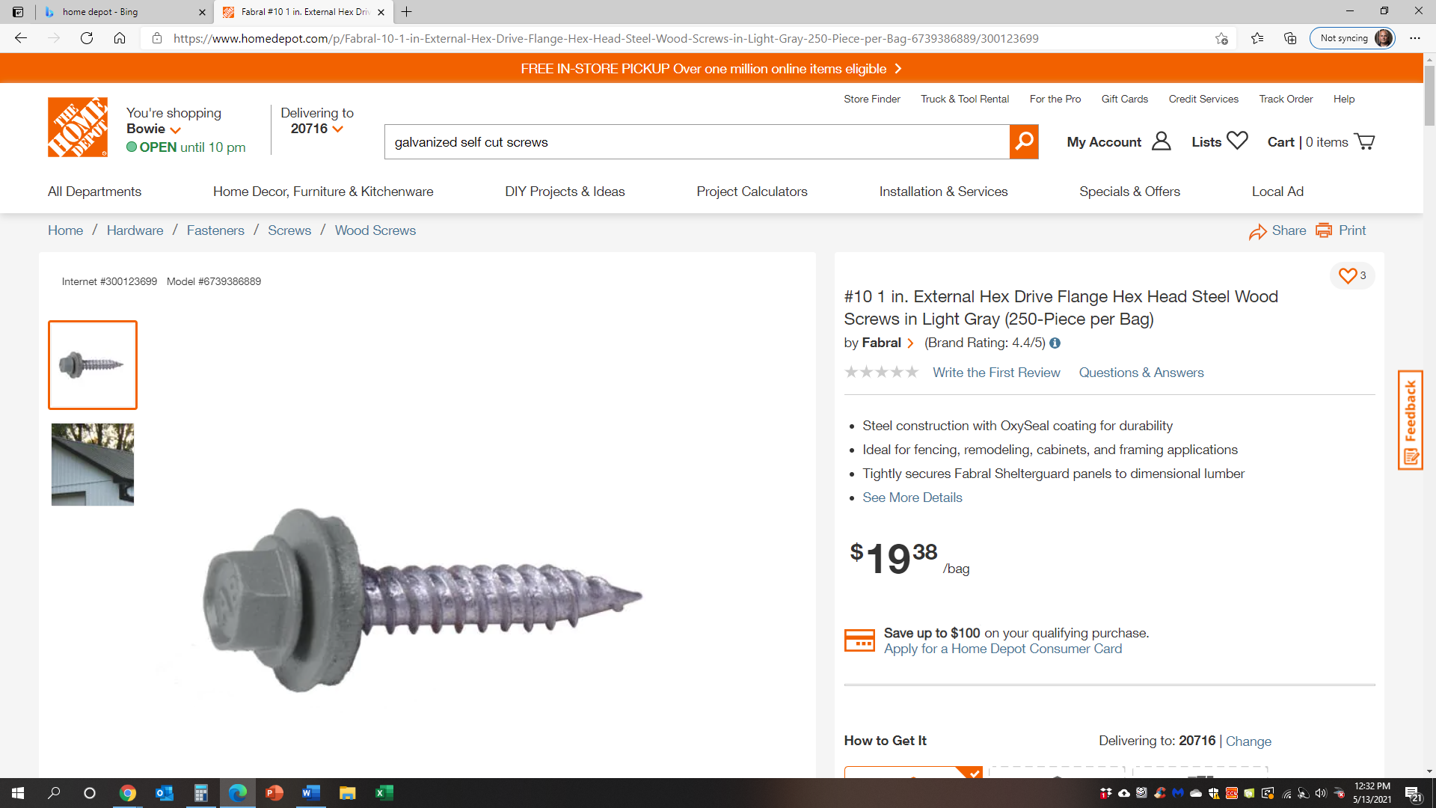
Extensions
Qty. 44 / 2.5” x 24”
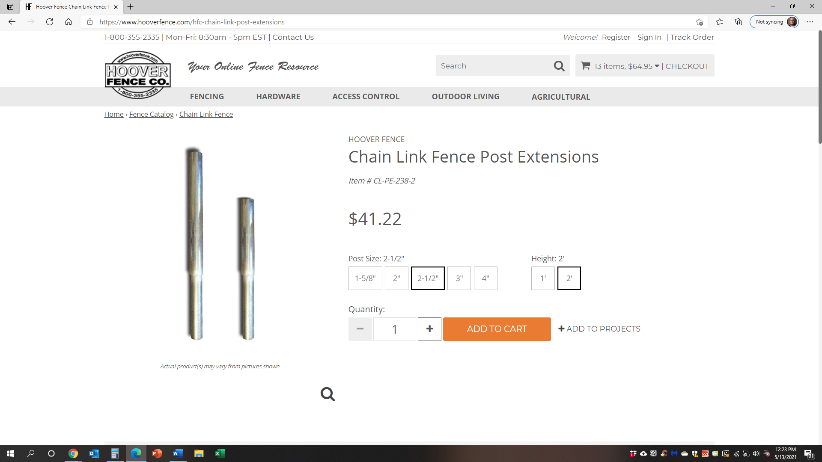

Qty. 6 / 3” x 24”
