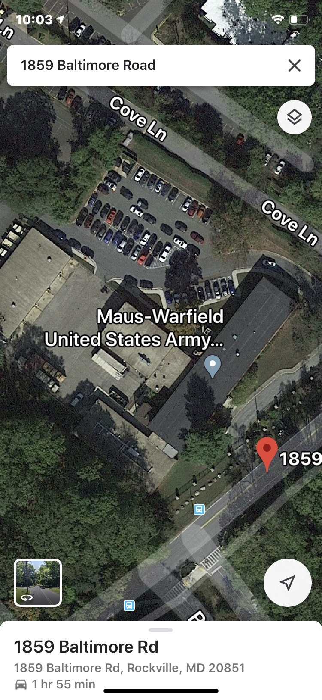
Area’s where rain water is getting into building, Check flashing where the buildings join together. Tar may be dried out.

