Replacement parts—the end are now stainless steel

0028700 for the hinge that comes as a pair.

12-0005188-005 for the acrylic

Part # 12-0005188-005 sneeze guard list $76.46 ea net $ 57.35 ea

Part # 0028700 BRACKET-SNEEZE GUARD *PAIR* list $63.13 per pair net $ 47.35 per pair

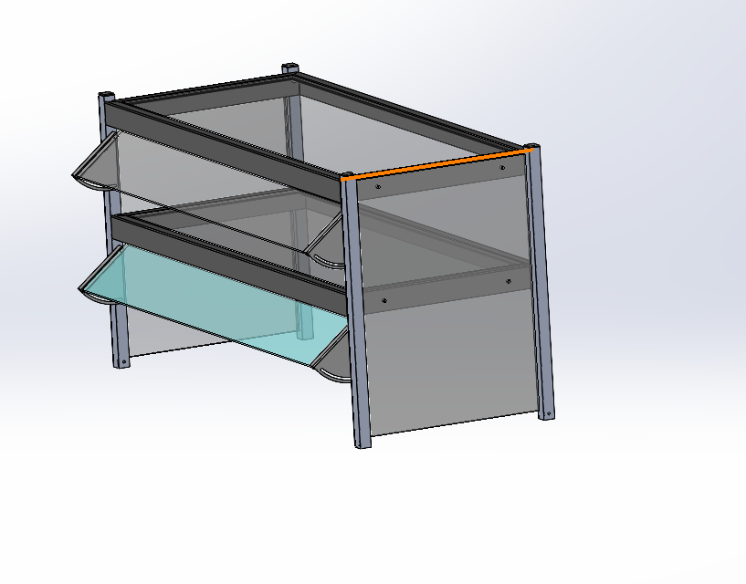

Douglas Repking Specialist, Technical Services
300 S 84th Ave, Wausau, WI 54401
Desk +1 (715) 848-9615 Office +1 (800) 544-3057


